Introduction to R

R is an open source language with over 2 million users worldwide that is becoming the leading programming language in statistics and data science. Every year, the R user basis is growing by 40% and an increasing number of organizations are using it in their day-to-day activities.

**Basic Stuff**

**Alt** + **-**

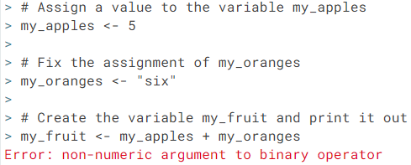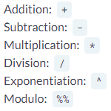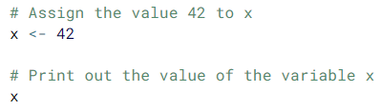

**understand the general nature of this error message**

shortcut for the <- assignment operator

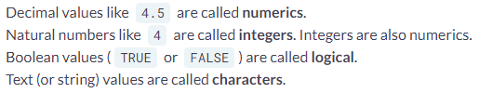

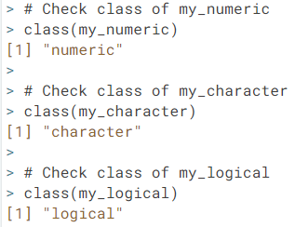

class()

c()

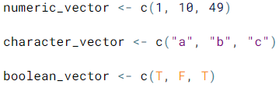

names()

**R is case sensitive**

**Vectors**

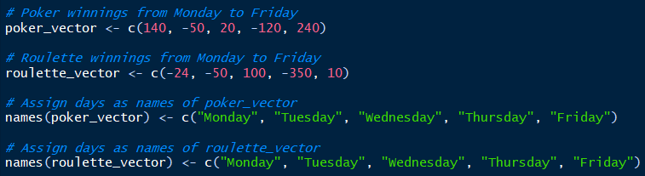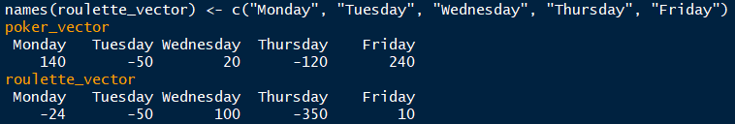

**Vector Math**

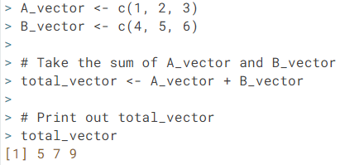

**CAREFUL  
R adds vector by position ONLY. If you give the vectors names, R will NOT add elements based on the names associated with each element.**

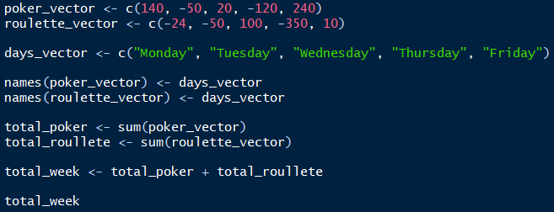

You can test whether one value is greater than another 🡺 total_poker > total_roulette

sum()

What happens when you run 🡺 poker_vector > roulette_vector ?

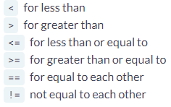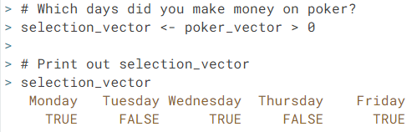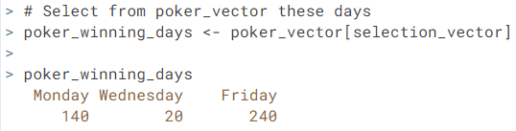

**Vector Element Selection**



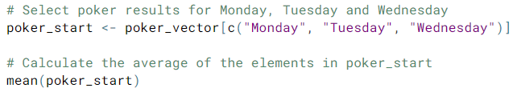

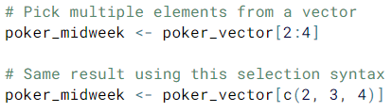**Matrices**

mean()

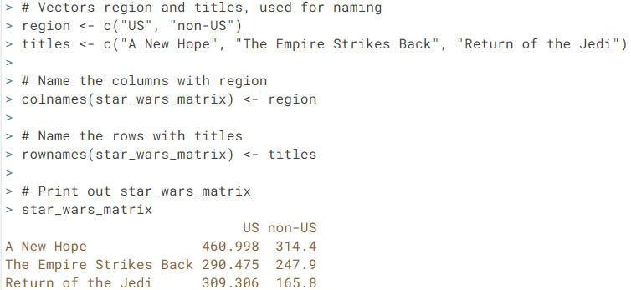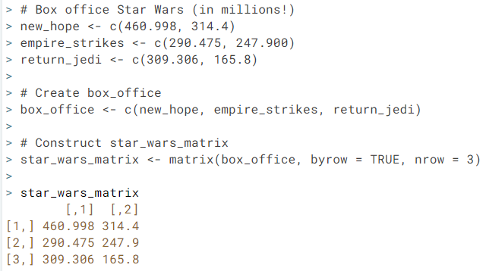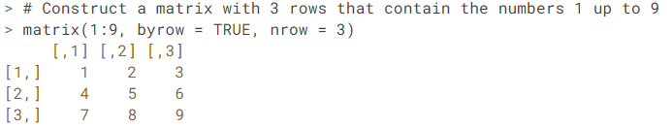A matrix is a collection of elements of the same data type  
that is arranged in rows by columns (m x n)

colnames()

rownames()

matrix()